# 1-Getting Started

## Investigate an IoT project

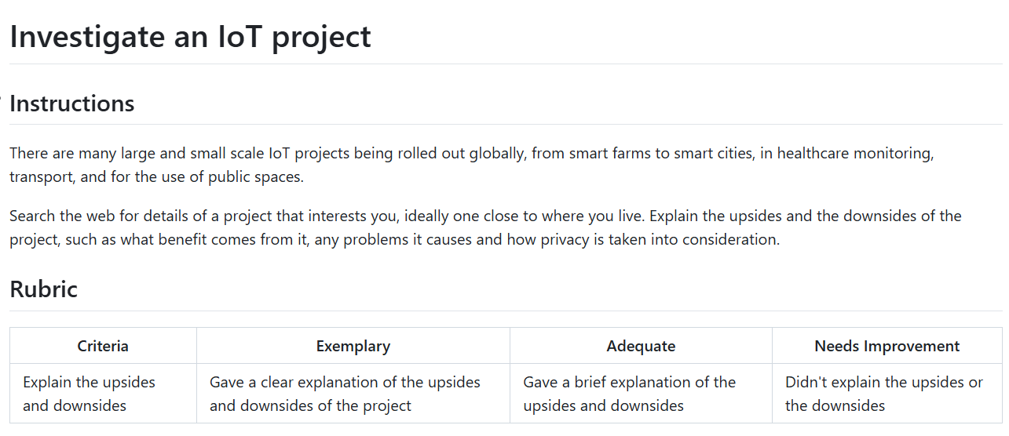

**Project about air level control at VGU:**

Upsides:

1. Measuring the air level will improve the health and safety of students and staff around VGU. These IoT devices would alert people in hazardous conditions. Thus reducing the risks of respiratory.
2. Allowing real-time monitoring by providing continuous updates on air quality and pressure around the school, it would allow school managers to give immediate response in emergency situations.
3. These devices are connected to alarms systems where they can trigger ventilation that alarm students and staff in emergency situations.
4. This Iot network can cover wide areas making it easy to expand monitoring without huge infrastructure costs.

Downsides:

1. Cost would be put in consideration since the cost of maintaining, setup, and software can be pricey. Moreover, they would need calibration to stay accurate.
2. Sensor malfunctions or environmental interference (e.g., weather) might lead to inaccurate readings, triggering unnecessary alarms or missing real threats.
3. These devices need a constant power source. In outages or remote areas, battery life or backups become a limiting factor.

## 2. Compare and contrast microcontrollers and single-board computers

|  | **Microcontrollers** | **Single-board computers** |
| --- | --- | --- |
| **Cost** | More affordable, suitable for large-scale deployments | Quite costly due to its components and enhanced capabilities |
| **Connectivity** | More basic connectivities options, some would supporting Wifi and Bluetooth | More advanced connectivities for example: Wifi, Bluetooth, Ethernet |
| **Power Consumption** | Low power consumption, ideal for battery-operated or energy-efficient applications | Higher power consumption, often requiring a constant power source |
| **Size** | Compact and lightweight, easily integrated into small devices | Larger, not ideal for space-constrained applications |
| **Processing power** | Limited processing since it’s optimized for specific, low-power tasks | Higher processing since it’s build to handling complex computations and multitasking |

**Why choose microcontrollers?**

1. Microcontrollers are energy efficient since they’re designed for low-power operations such as IoT level control sensors that need to operate on battery power or places with limited energy access.
2. The cost of microcontrollers such as Arduino, or ESP32 would allow for broader deployment which would be particularly advantageous for large-scale environmental monitoring projects where budget constraints are a concern.

**Why choose single-board computers?**

1. Single-board computers are known for their advanced data processing capabilities, for example in the case of IoT air level monitoring, by running machine learning algorithms, it would result in giving detailed analysis of air quality trends or predictions. Leads to improving response times since it doesn’t need constant data transmission of microcontrollers.
2. Single-board computers allow extensive connectivity options which are suitable for applications requiring integration with multiple sensors. Such as a single-board computer can manage a network of air level sensors while simultaneously hosting a web server to display real-time data.

## 3. Research sensors and actuators

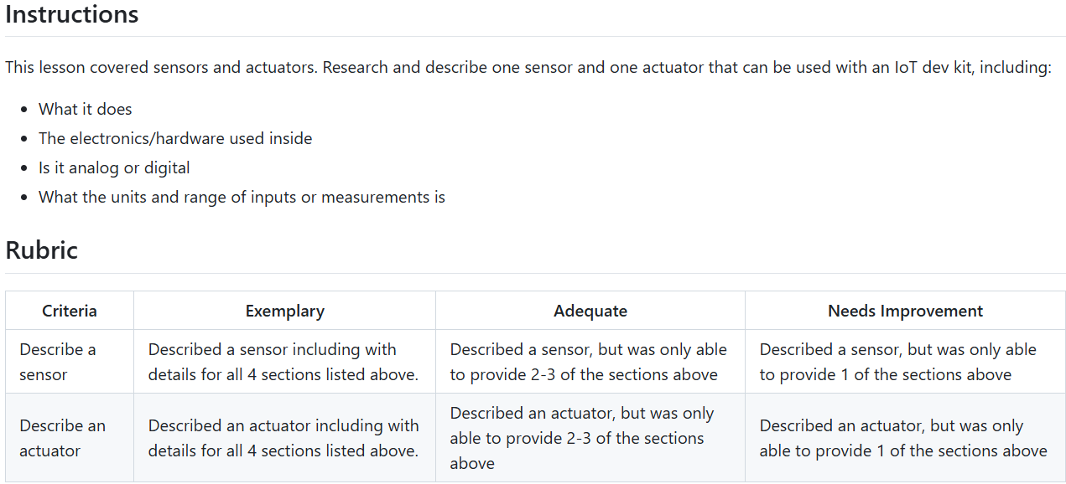

**Sensor used with an IoT dev kit: MQ-135 Gas Sensor:**

**What it does:**

* This sensor is designed to detect a wide range of gases including smoke, CO2. It’s a useful sensor for monitoring air quality by detecting harmful pollutants.

**The electronics/hardware used inside:**

* Consist of a tin dioxide (SnO2) which exhibits a change in resistance when exposed to target gases, a heater coil to maintain sensing element at optimal temperature, a signal output analog or digital, a voltage divider circuit for signal output.

**Is it analog or digital:**

* Well the MQ-135 provided an analog output proportional to the gas concentration. Some may include a digital output but normally it would be analog.

**What the units and range of inputs or measurements is:**

* This sensor in ppm, as for the CO2 gas, normally ranges from 10-1000 ppm, as for ammonia, 10-300 ppm.

**Actuator used with an IoT dev kit: SG90 Micro Servo Motor:**

**What it does:**

* Control angular or linear position, and acceleration. Some carry out task of this could be opening a door, camera rotation.

**The electronics/hardware used inside:**

A servo motor comprises a miniature DC motor, a position sensor (often a potentiometer), and a control circuit. Get feedback from the position sensor to adjust its position as commanded by the input signals.

**Is it analog or digital:**

Well it is digital, controlled by the PWM signal. But the internal potentiometer is an analog component.

**What the units and range of inputs or measurements is:**

Signal input is PWM (50hz) rotation range is from 0 degree to 180 degrees, 4.8-6V DC.

## 4. Connect-Internet:

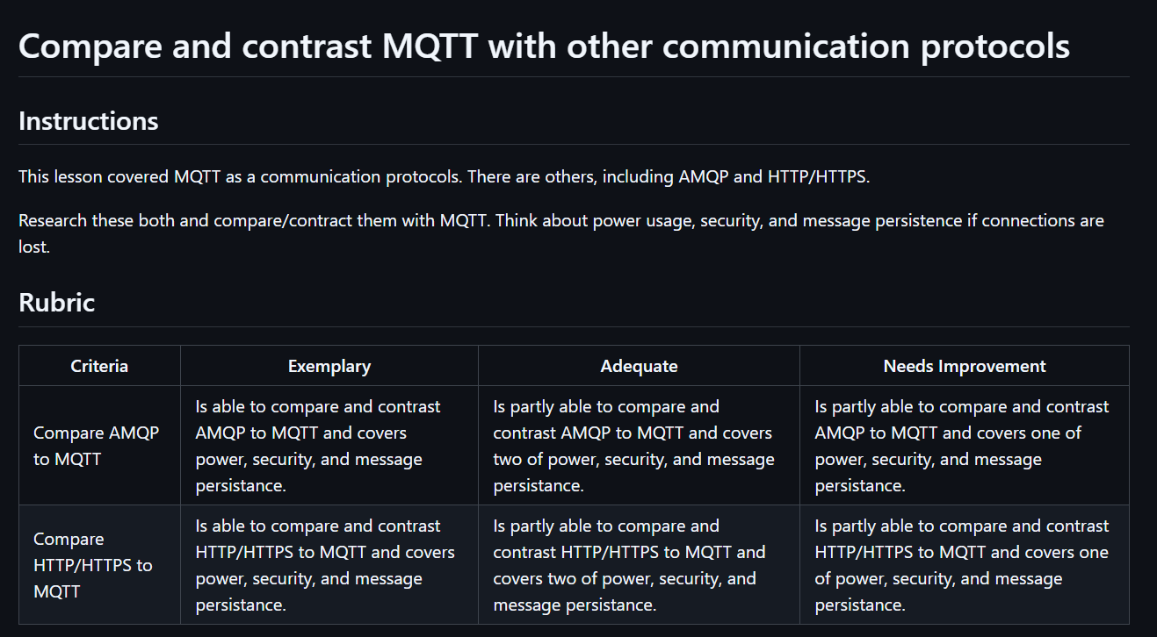

**Compare AMQP to MQTT:**

|  | **MQTT** | **AMQP** |
| --- | --- | --- |
| **Power** | - optimized for minimal power consumption.  - maintains an open connection with minimal overhead through persistent sessions and lightweight message headers | - more resource-intensive due to its verbose specification and higher protocol overhead, thus making it less ideal for constrained environments. |
| **Security** | - support TLS for secure communication | - support TLS for secure communication  - Simple Authentication and Security Layer (SASL), allows for more granular authentication mechanisms. |
| **Message persistence** | - three Quality of Service (QoS) levels, can help developers to trade off between delivery assurance and resource usage.  - supports retained messages and persistent sessions. | - excels in this area with built-in message queuing, acknowledgments, and transactions, offering highly reliable and persistent communication suitable for mission-critical systems. |

**Compare AMQP to HTTP/HTTPS:**

|  | **MQTT** | **HTTP/HTTPS** |
| --- | --- | --- |
| **Power** | - Less bandwidth and computational power compared to HTTP.  - ideal for devices with limited processing capability and intermittent network connectivity. | - involves frequent connection establishment and teardown → higher power assumption. |
| **Security** | - support TLS for secure communication | - support TLS for secure communication.  - widely trusted and deployed for secure web communications.  - smaller attack surface and persistent session management can make it more secure in constrained environments, provided proper configuration. |
| **Message persistence** | - Supports persistent sessions and retained messages | - No native message persistence; requires external handling |

# 2-farm

## 1-Predict-plant-growth:

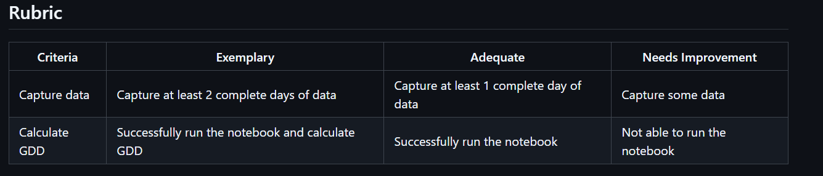

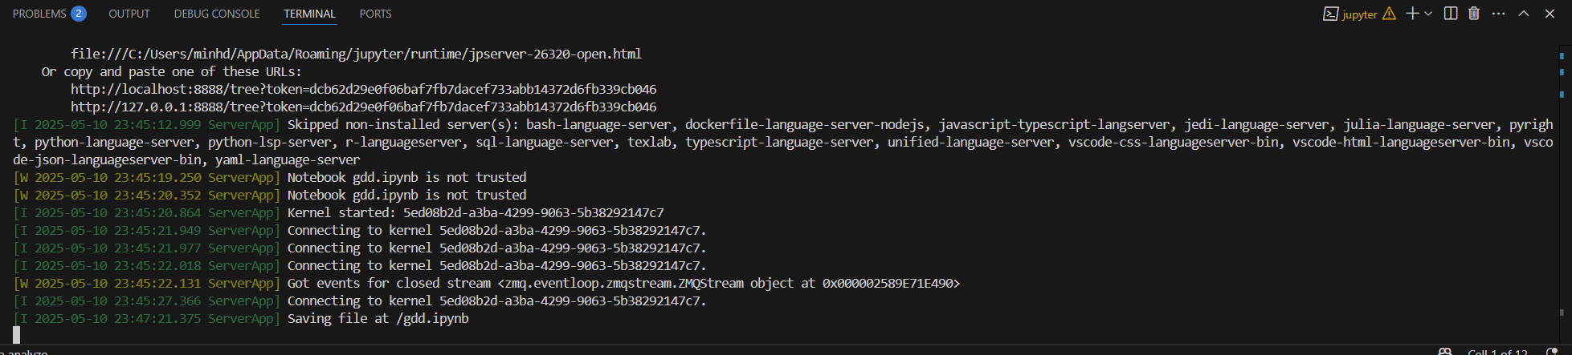

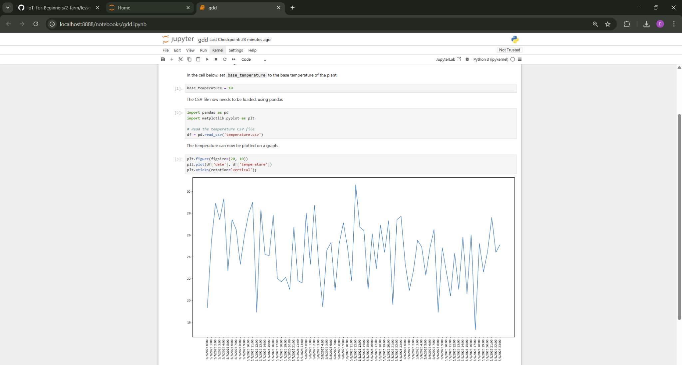

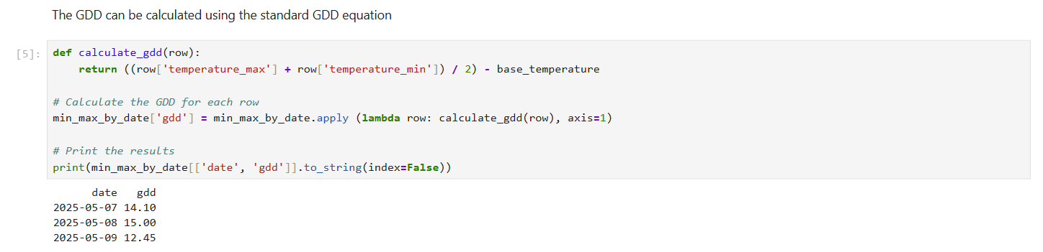

## 2-Detect-soil-moisture

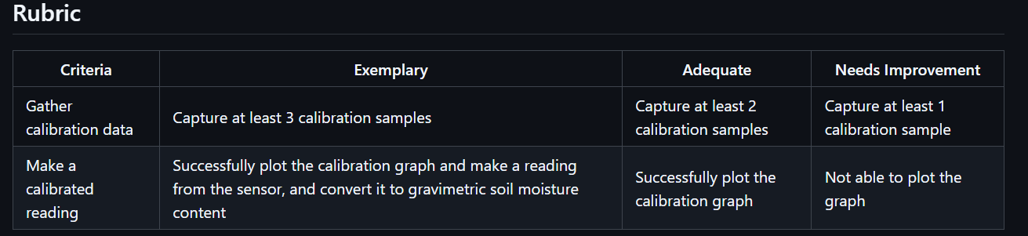

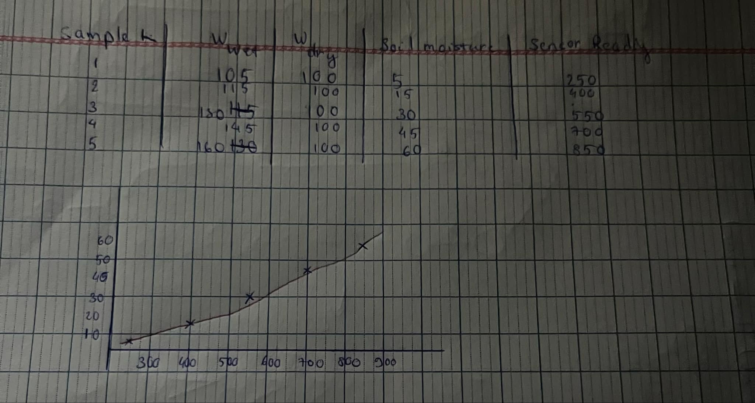

## 3-automated-plant-watering:

Please check in github

## 4-Migrate your plant to the cloud

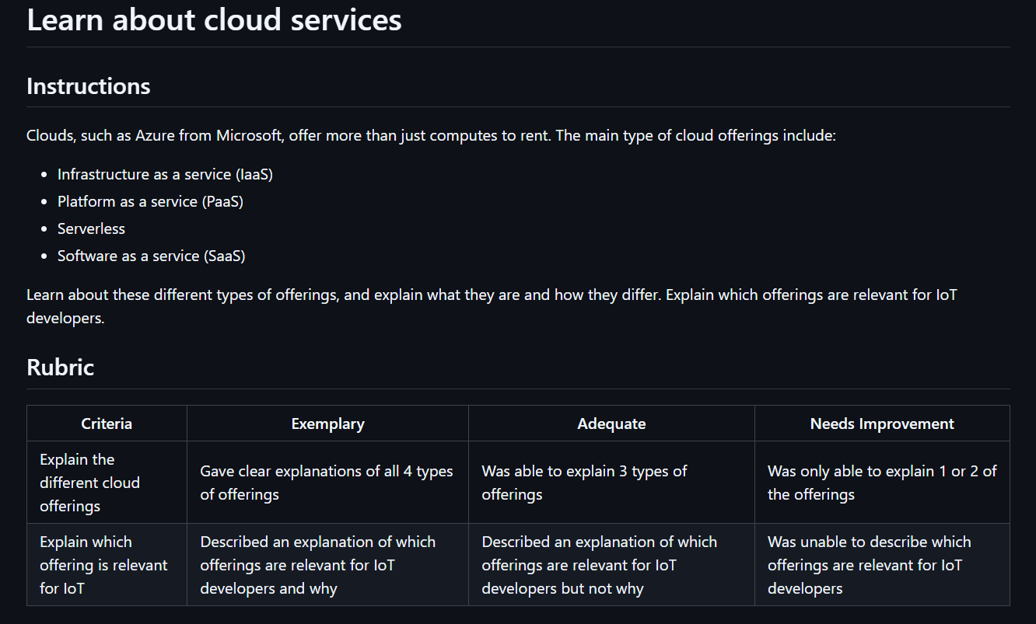

**Infrastructure as a Service (IaaS):**

* IaaS provides essential computing resources including virtual machines, storage, and networking infrastructure over the internet. It lets users rent and manage physical or virtual servers without investing in on-premises hardware. An example of it would be Microsoft Azure Virtual Machine or AWS EC2.

**Platform as a Service (PaaS):**

* Without having to worry about maintaining the underlying infrastructure, PaaS provides a platform with services and tools for creating, testing, and deploying applications. To allow developers to concentrate on code and logic, it abstracts away a large portion of system administration. Examples would be Azure App Service, Google App Engine.

**Serverless:**

* Server management is completely abstracted by serverless computing. Users are only charged for the execution time of the code, which runs in reaction to events (such as sensor data or API calls). It is economical and scalable for managing irregular or event-based workloads. Examples would be Azure Functions or AWS Lambda.

**Software as a Service (SaaS):**

* SaaS offers fully functional software that is available online, frequently through a subscription model. Users are not concerned about application changes or the underlying infrastructure. Examples would be Microsoft 365, Salesforce, or Azure IoT Central.

Offering that are relevant for IoT would be Serverless is highly relevant because IoT applications often need to respond to events (e.g., sensor threshold breaches) in real time with minimal resource usage and cost, PaaS is useful for managing and deploying APIs or dashboards for IoT systems without having to worry about infrastructure. SaaS offerings like Azure IoT Central are especially helpful for developers who want to rapidly prototype and manage IoT devices without building custom infrastructure.

**Why?**

Because Serverless allows cost-efficient, event-driven processing of IoT data, PaaS simplifies deployment of cloud services needed to interact with IoT devices, and SaaS accelerates development and monitoring through pre-built solutions tailored for IoT.

## 5-Migrate your application logic to the cloud

On github

# 3-Transport

## 1-Location-tracking

**output(1).nmea and location-tracking.python** file

## 2-Store-location-data

**Investigate-function-bindings** file

## 3-visualize-location data

**.github/workflow** file

## 4-geofences

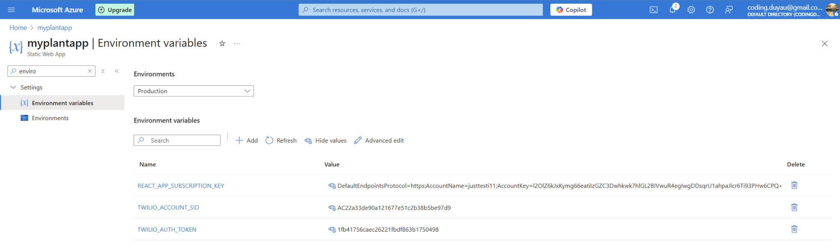

**Function.json and index.js in .github/workflow** file

# 4-manufacturing

## 1-train-fruit-detector:

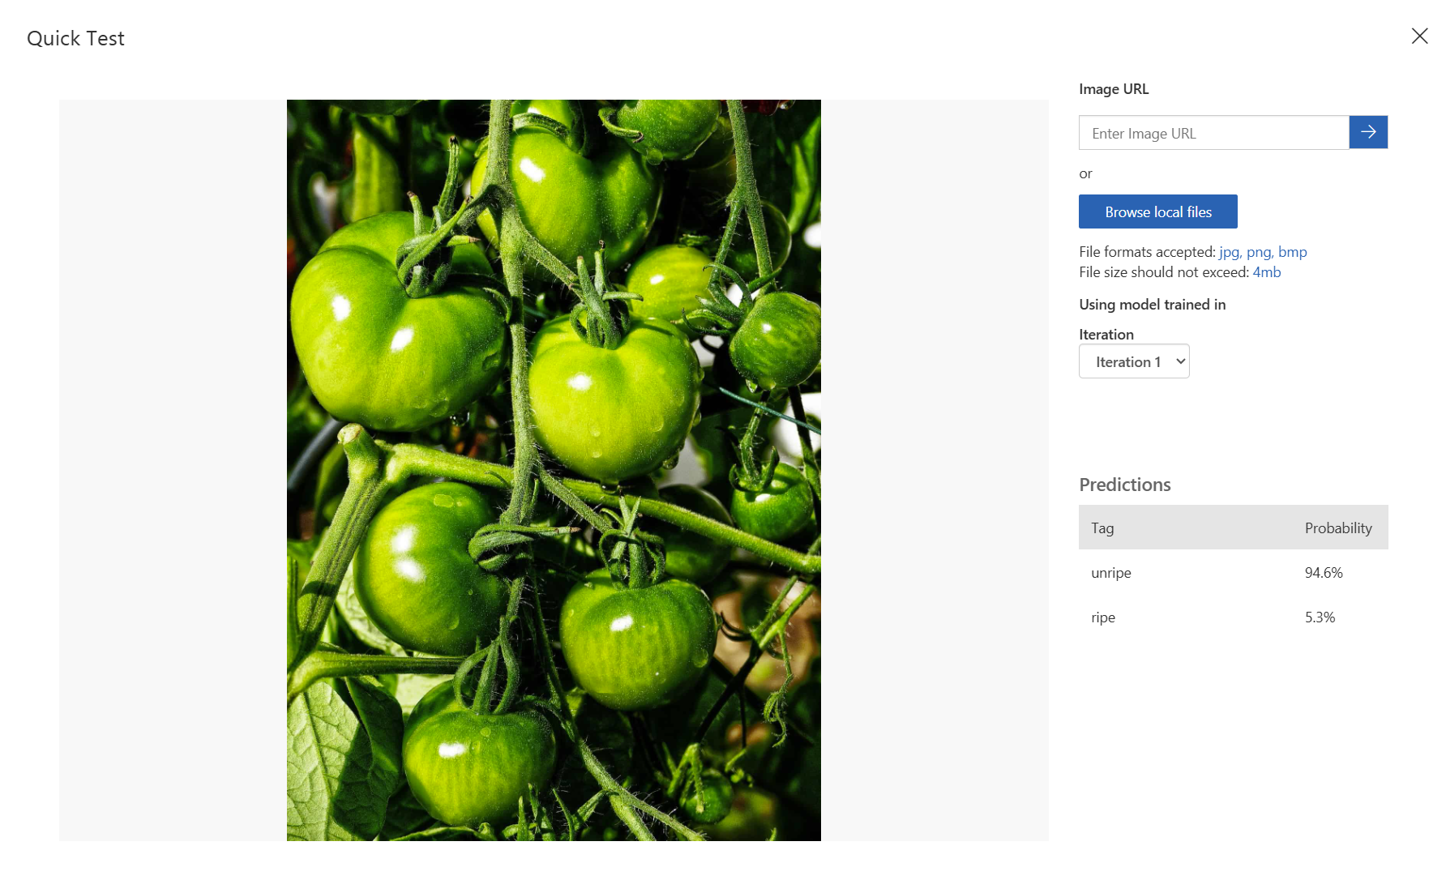

# 5-retail

## 1-train-stock-detector

**Domain 1:** Products on Shelves

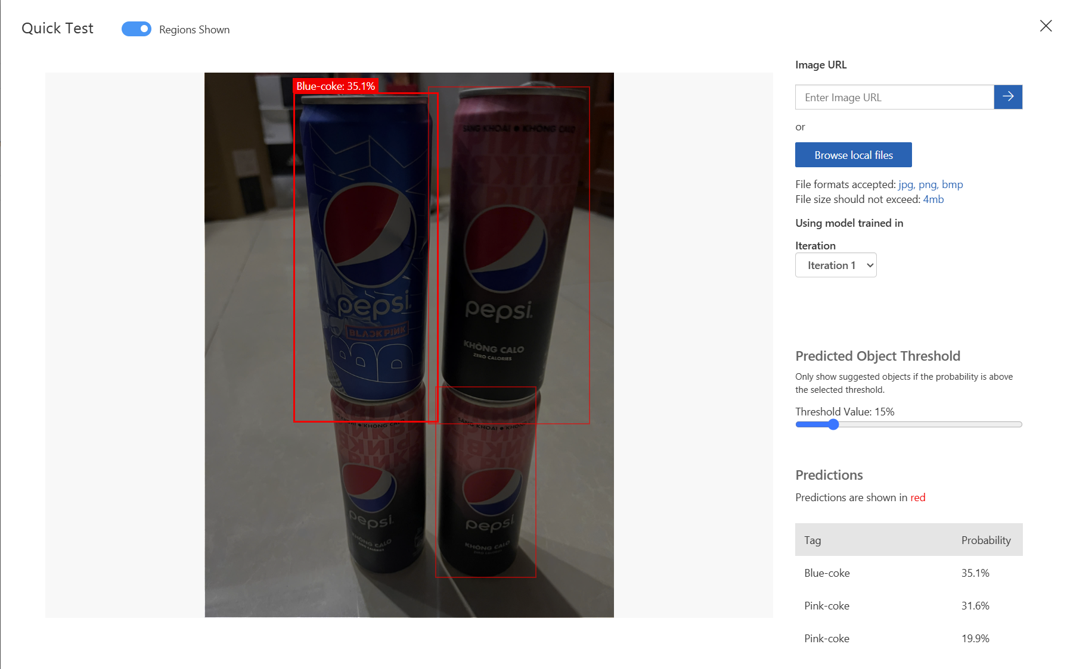

**Domain 2:** General

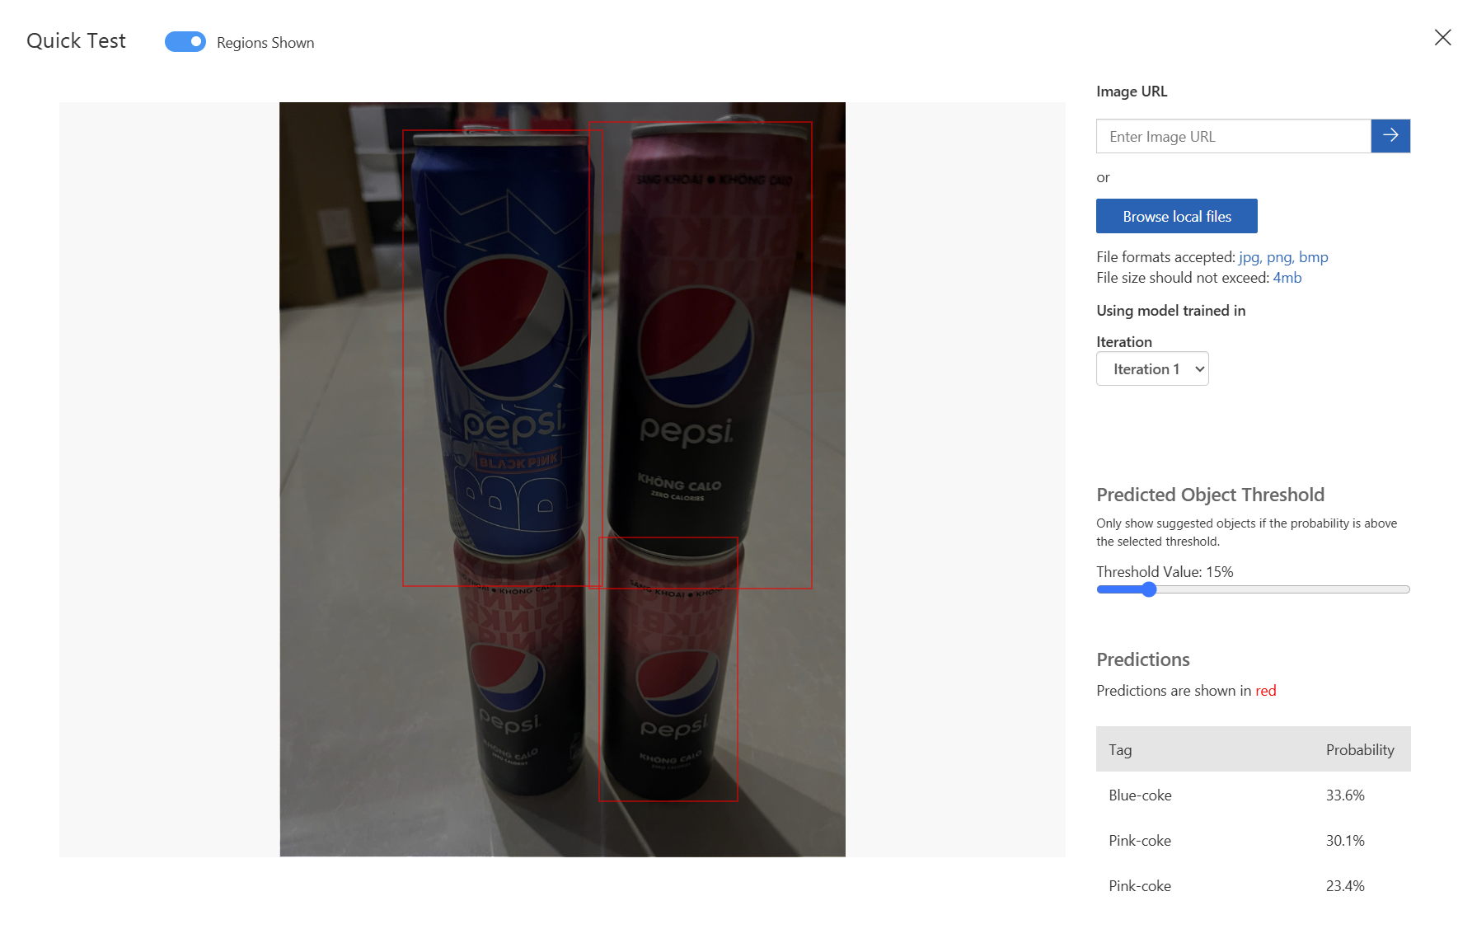

Compare both result, I could conclude that the domain Products on Shelves are more accurate compared to the General Domain as the prediction for each type of coke for ex, product on shelves domain produced 35.1% while on General domain only 33.6%, and 31.6% and 30.1% on the Pink-coke

## 2-check-stock-device:

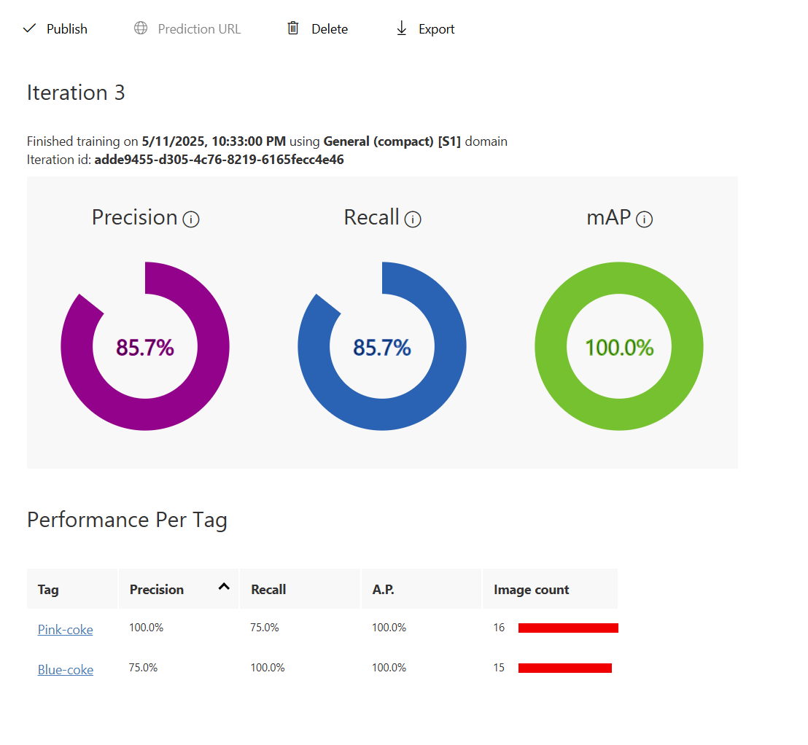

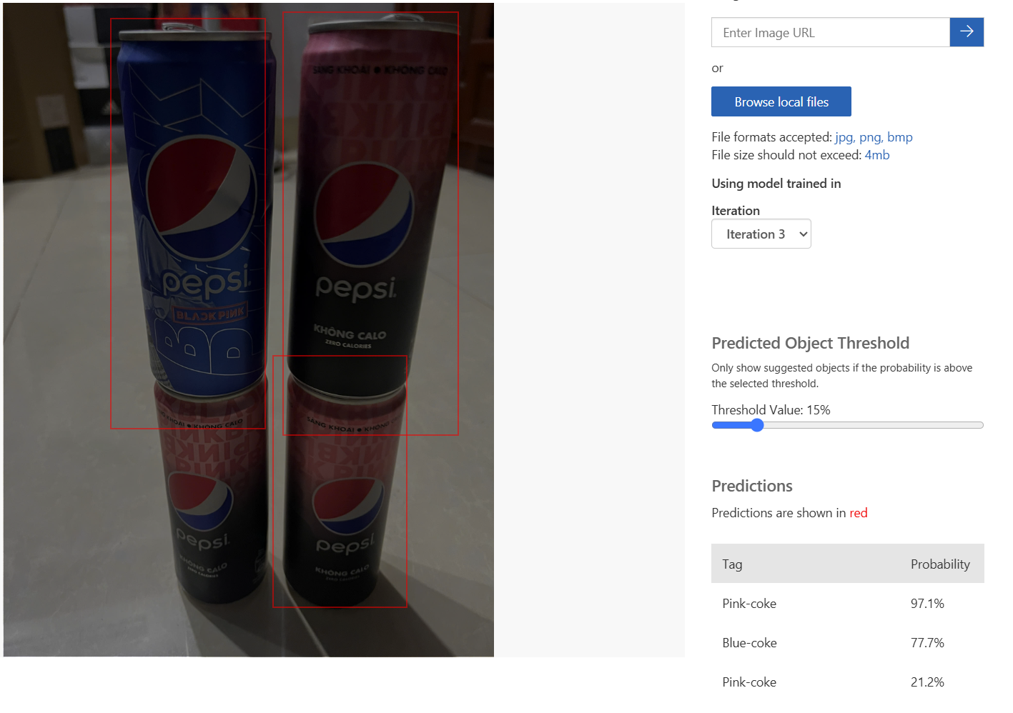

Please check the file **check-stock-device.py**

# 6-consumer

## 1-speech-recognition:

Non assignment in the github

2-language-understanding:

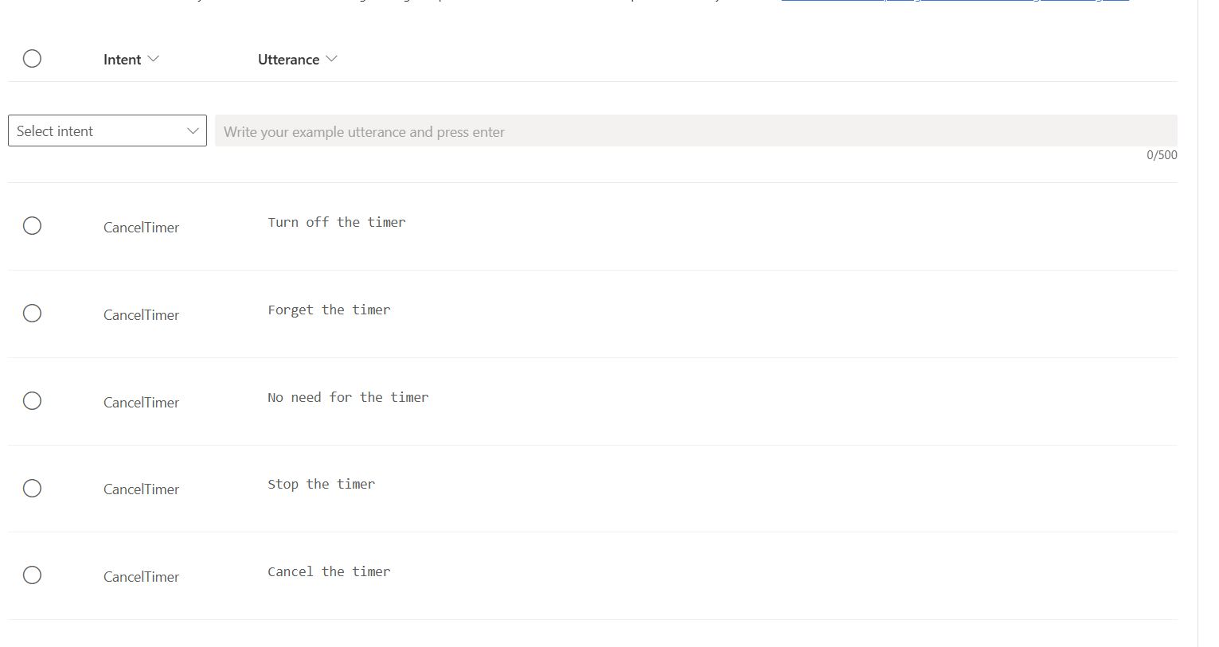

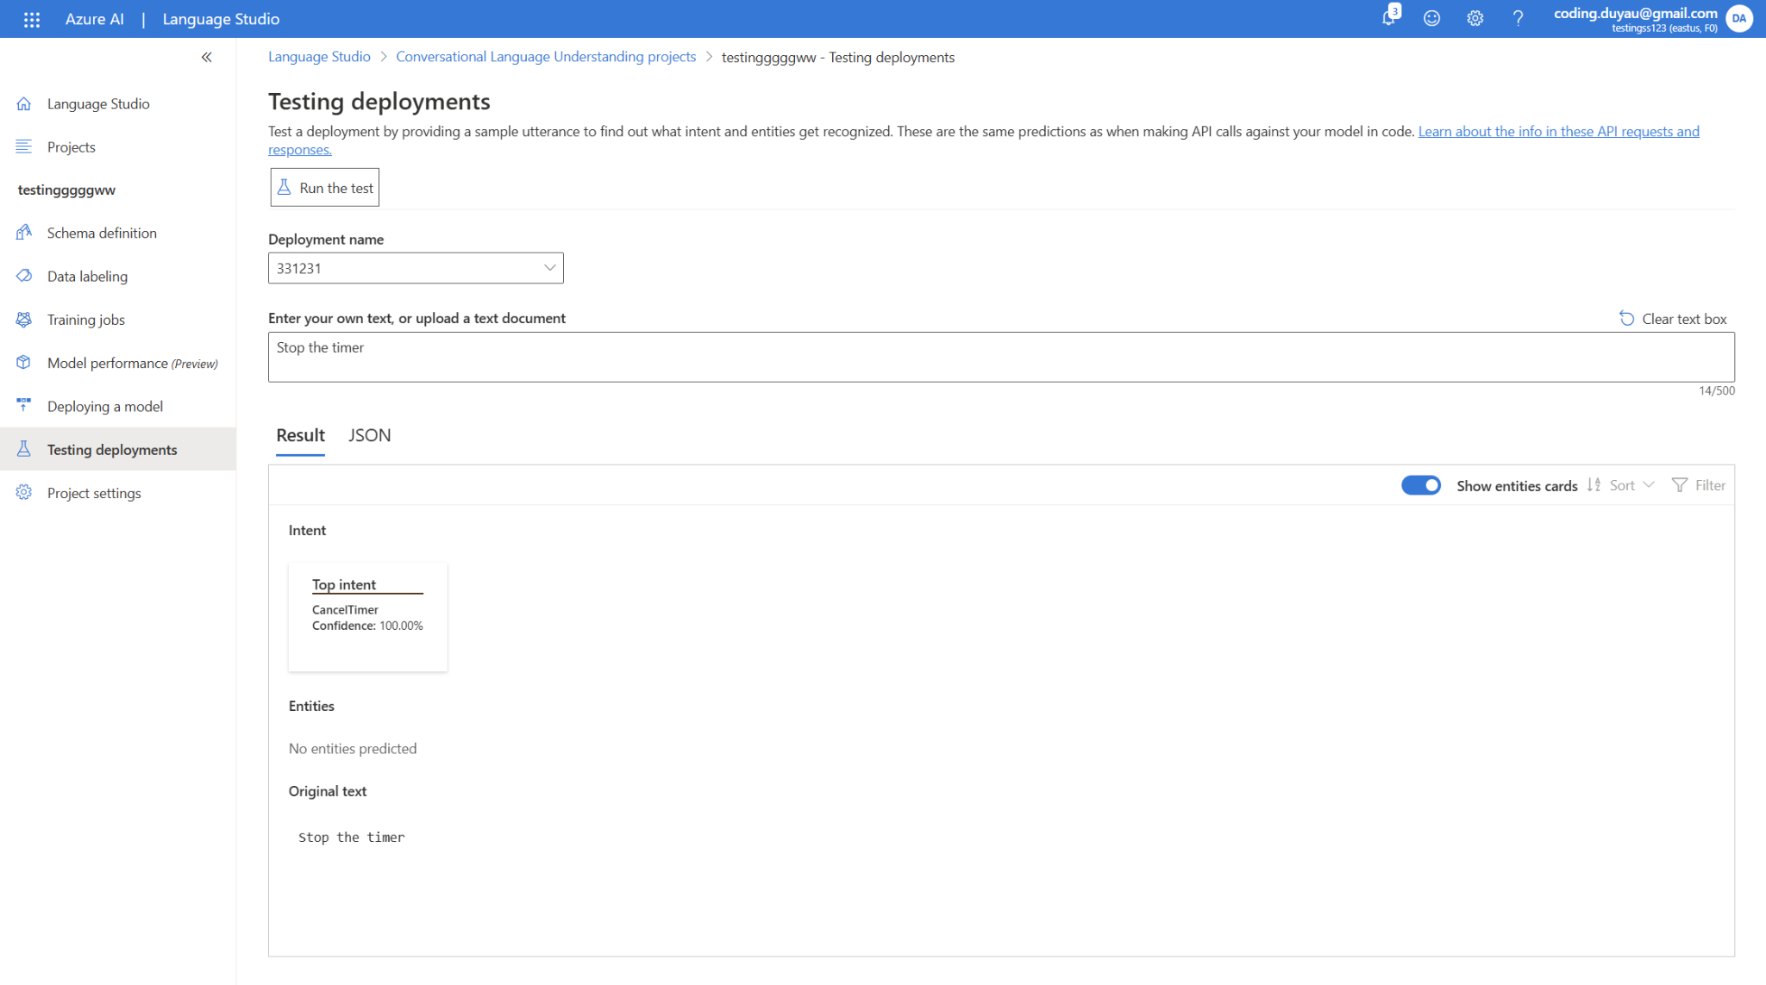

3-